**JAVA ASSIGNMENT 2: DAY 2: DT:20/07/2022:-**

Q:1) What is JIT ?

Ans:1)JIT stands for Just in time which is an integral part of the Java virtual machine.It converts high level language to machine language accordingly.

Example:



In this example we can see that since the interpreter checks each line at a time hence the 4th and 5th line being the same gets repeated which results in compromising on the optimization factor as a result we require the JIT compiler which would check for such redundancies and would eliminate if any resulting in optimization of the code.



We can see here that the JIT will eliminate the repeated lines and then pass on this .class file to the interpreter which in turn will then interpret the code line by line.

Q:2)Explore the .class file of any existing code and check it?

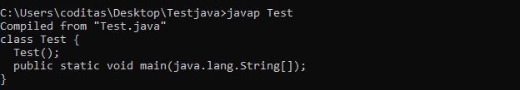

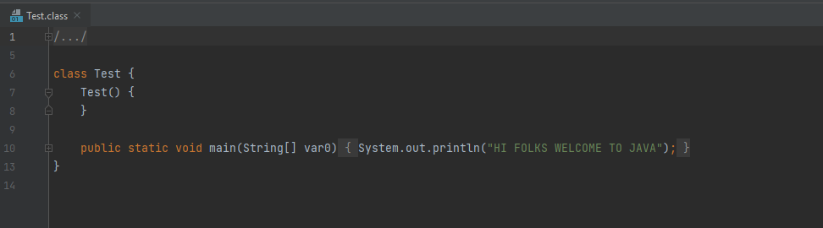

Q:3)Difference between access specifier and access modifiers?

Ans:3)**Java provides entities called “Access Modifiers or access specifiers” that help us to restrict the scope or visibility of a package, class, constructor, methods, variables, or other data members.**

* **These access modifiers are also called “Visibility Specifiers”.**

**Access modifiers:**

* **Default : When no access modifier is specified, it is treated as default modifier. Its scope is limited within the package.**
* **Public: The word itself indicates that it has scope everywhere, i.e; it is visible everywhere even outside the package.**
* **Private: It has scope only within the class**
* **Protected : Its scope limits within the package and all sub classes.**

**3. Non-access modifiers are those keywords which do not have anything related to the level of access but they provide a special functionality when specified.**

**4. Eg:- Final, Strictfp, Static, Abstract.**

Q:4)Can we have multiple main methods in class?

Ans:4)Yes we can have multiple methods in class as for example:

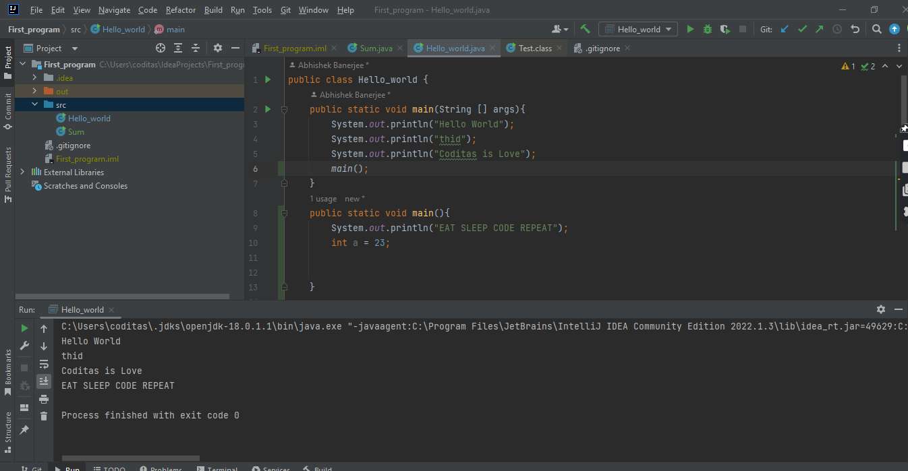

Q:5)Can we overload or overwrite the main method?

Ans:5)We can overload the main method but we cannot overwrite them as it is static in nature and as seen in the example given above we can overload the main method .

Q:6)Can we write the main method as private,protected and default?

Ans:6)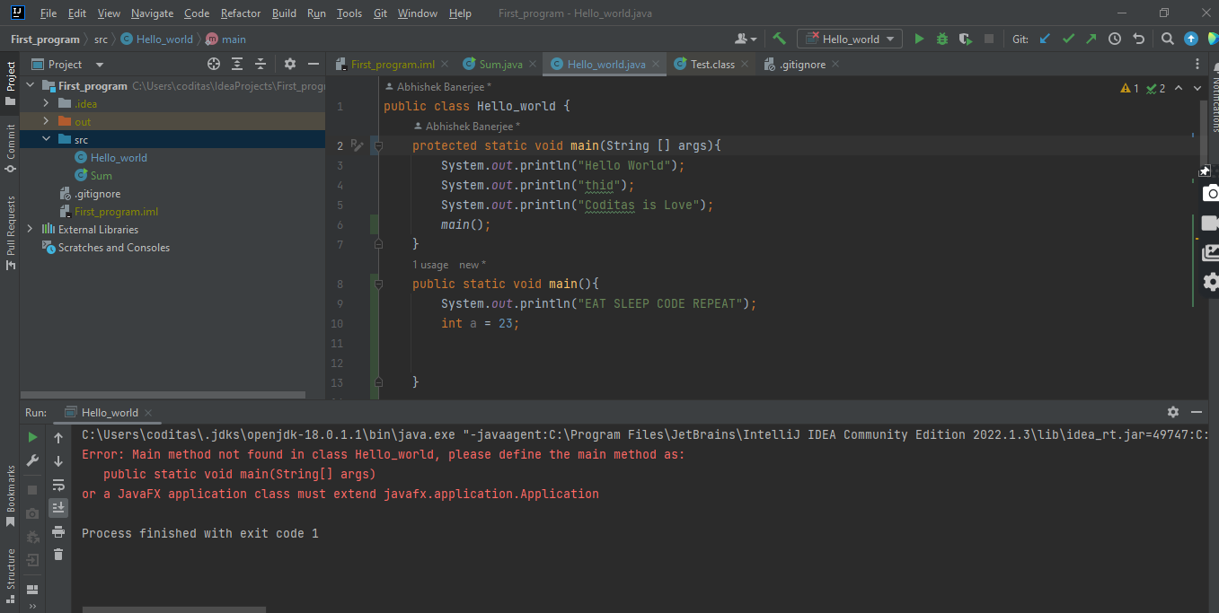

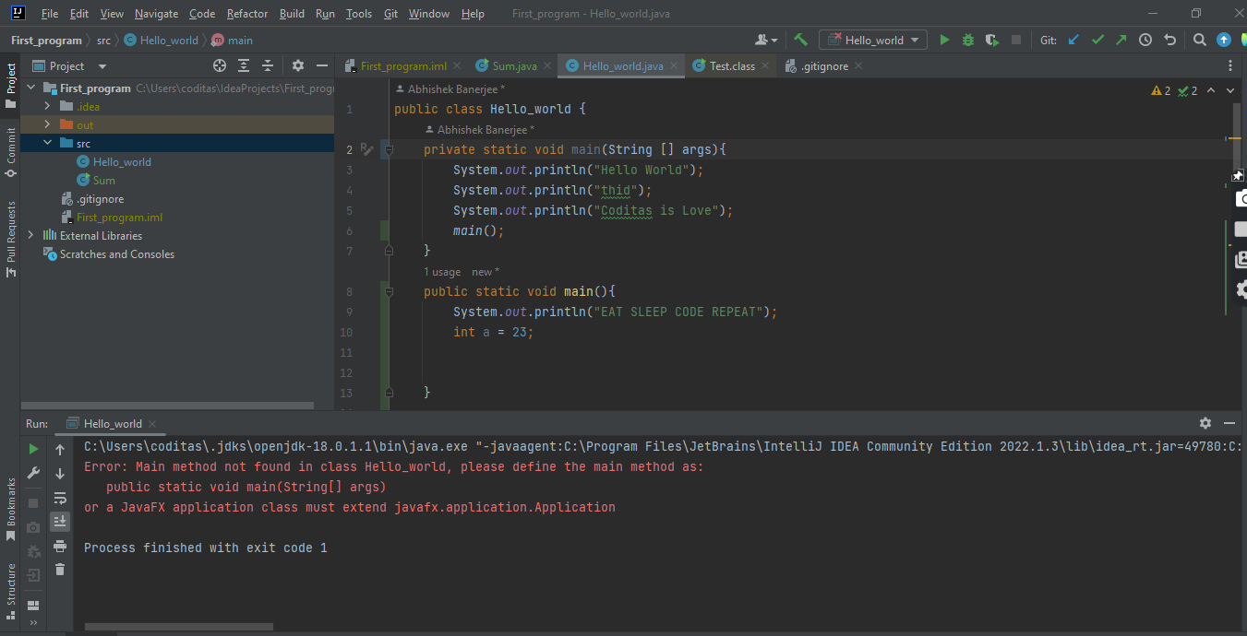

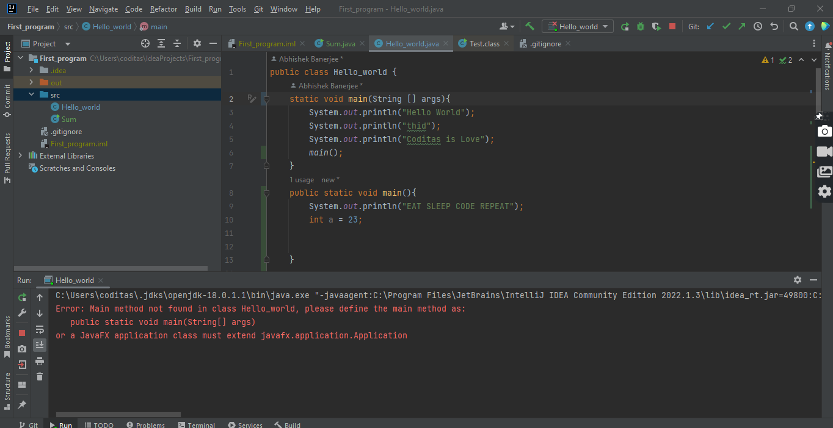

Q:9) Without a main method can we execute our code ?

Ans:9)Yes, we can execute a java program without a main method by using a static block.

Static block in Java is a group of statements that gets executed only once when the class is loaded into the memory by Java ClassLoader, It is also known as a static initialization block.

**But this will not execute with Java 7 version or later.**

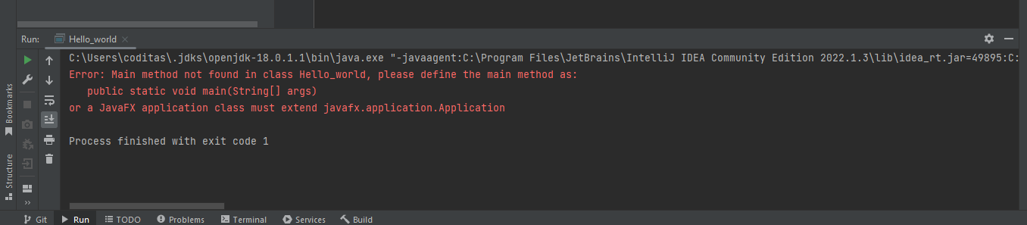

Q:10)Can we change the return type of the main method from void to any other return type?

Ans:10)You can return an int with System.exit().

Returning anything other than an integer doesn't make much sense, as the OS expects an integer. In case nothing is returned the default is 0, which means OK. Other values typically are used to signal errors or special conditions.

Ans:11) Explore keyword strictfp?

Ans:11)**Java strictfp keyword ensures that you will get the same result on every platform if you perform operations in the floating-point variable. The precision may differ from platform to platform. That is why the Java programming language has provided the strictfp keyword, so that you get the same result on every platform. So, now you have better control over the floating-point arithmetic.**